**CSA 1740 ARTIFICIAL INTELLIGENCE FOR COGNITIVE PSYCHOLOGY**

**OUTPUT**

**17 Write a Prolog Program to Sum the Integers from 1 to n.**

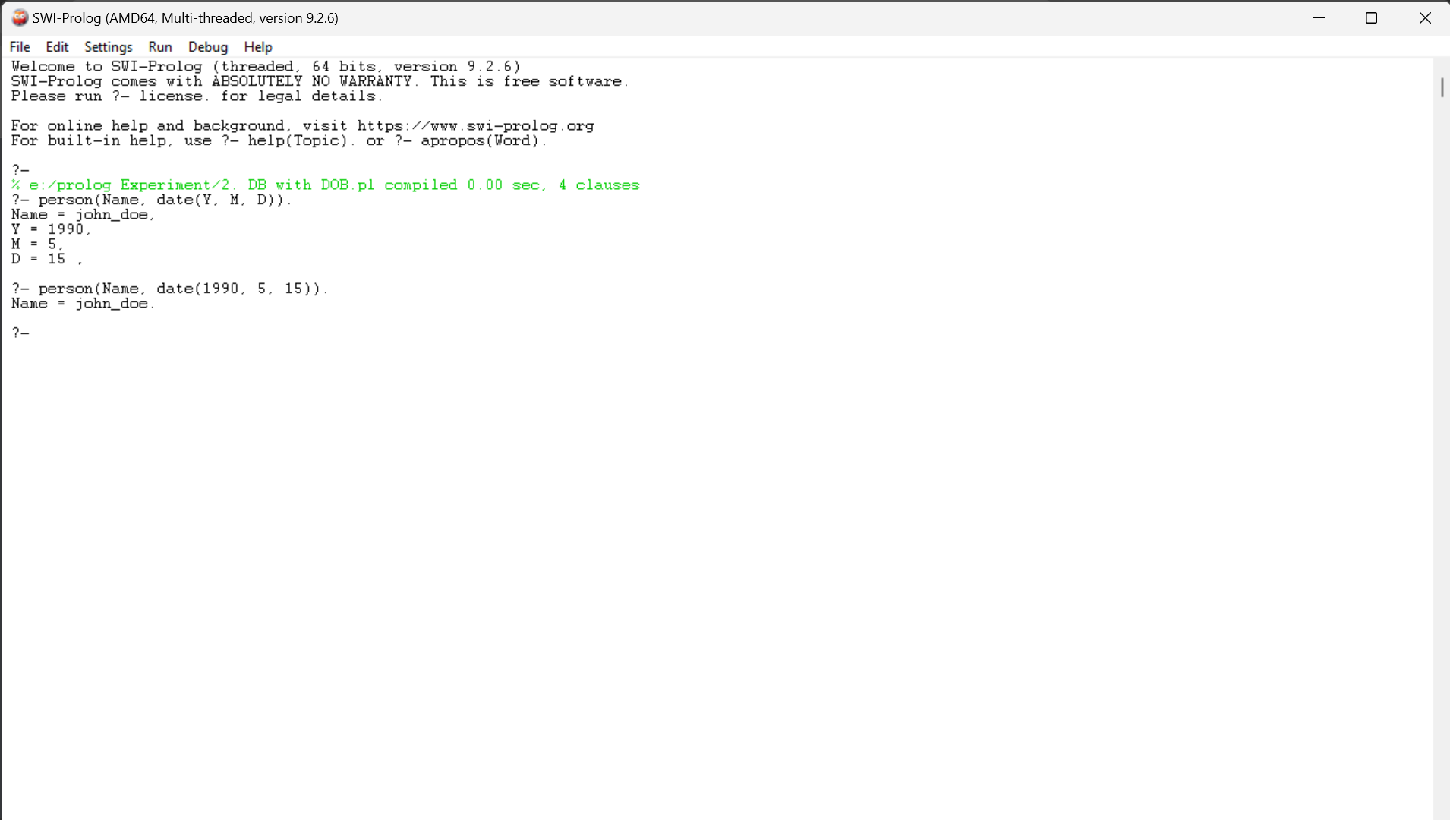

**18 Write a Prolog Program for A DB WITH NAME, DOB.**

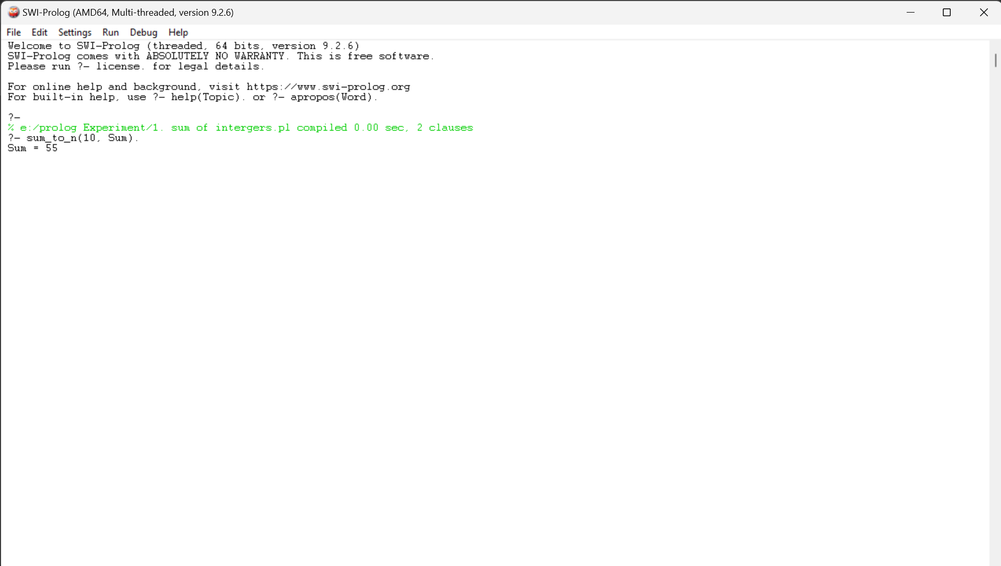

**19 Write a Prolog Program for STUDENT-TEACHER-SUB-CODE.**

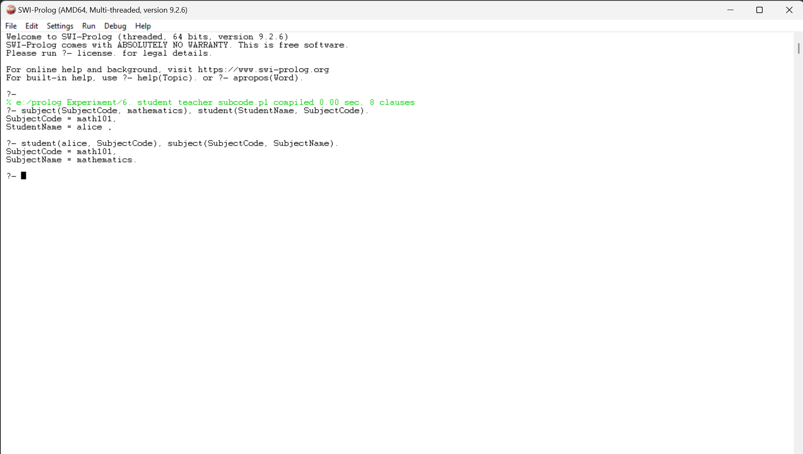

**20 Write a Prolog Program for PLANETS DB.**

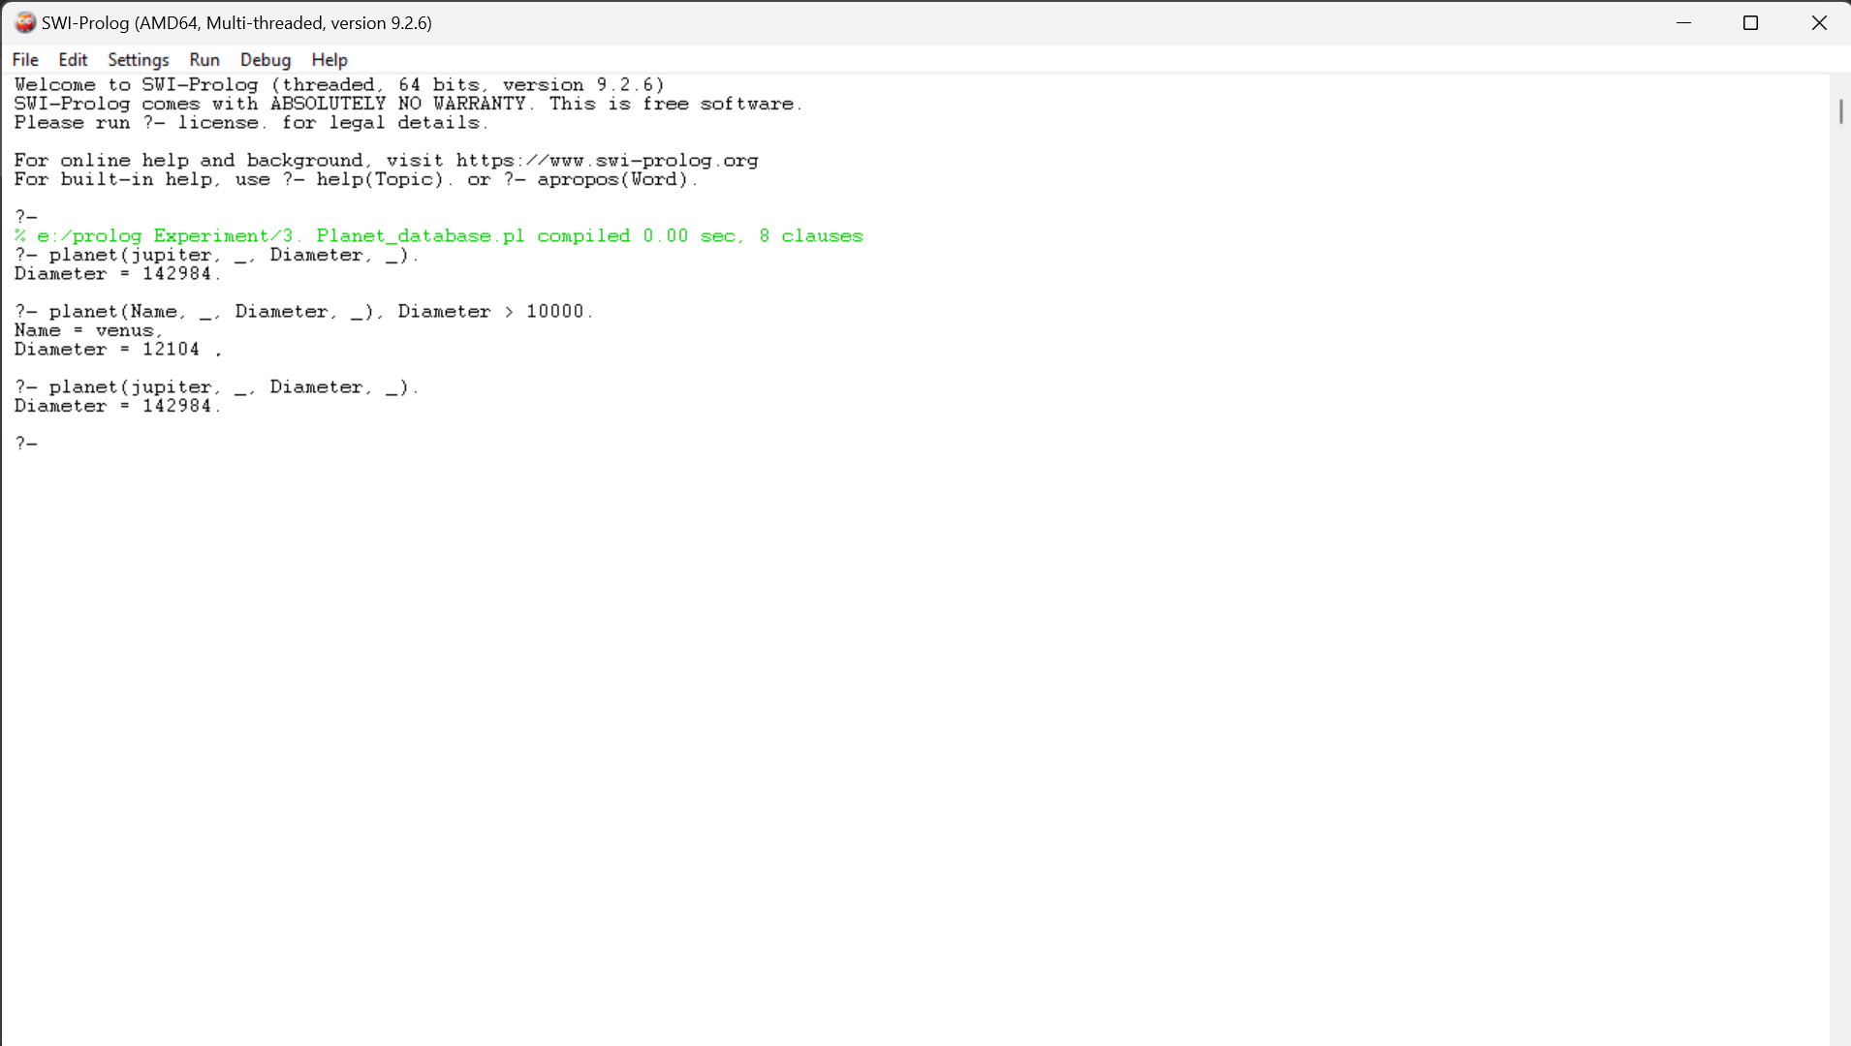

**21 Write a Prolog Program to implement Towers of Hanoi.**

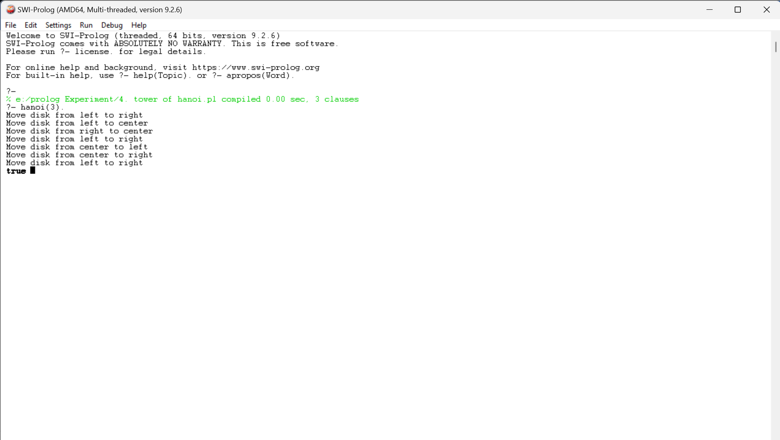

**22 Write a Prolog Program to print particular bird can fly or not. Incorporate required queries.**

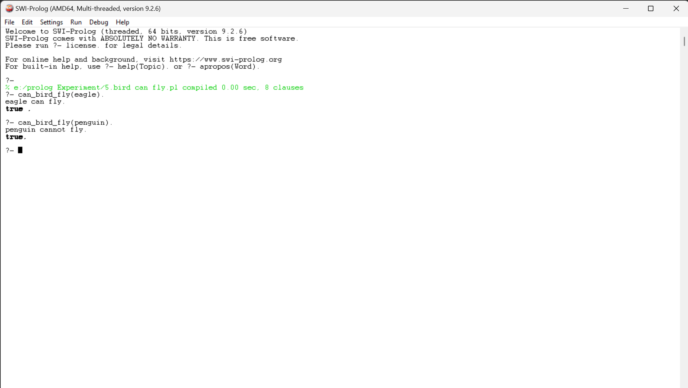

**23 Write the prolog program to implement family tree.**

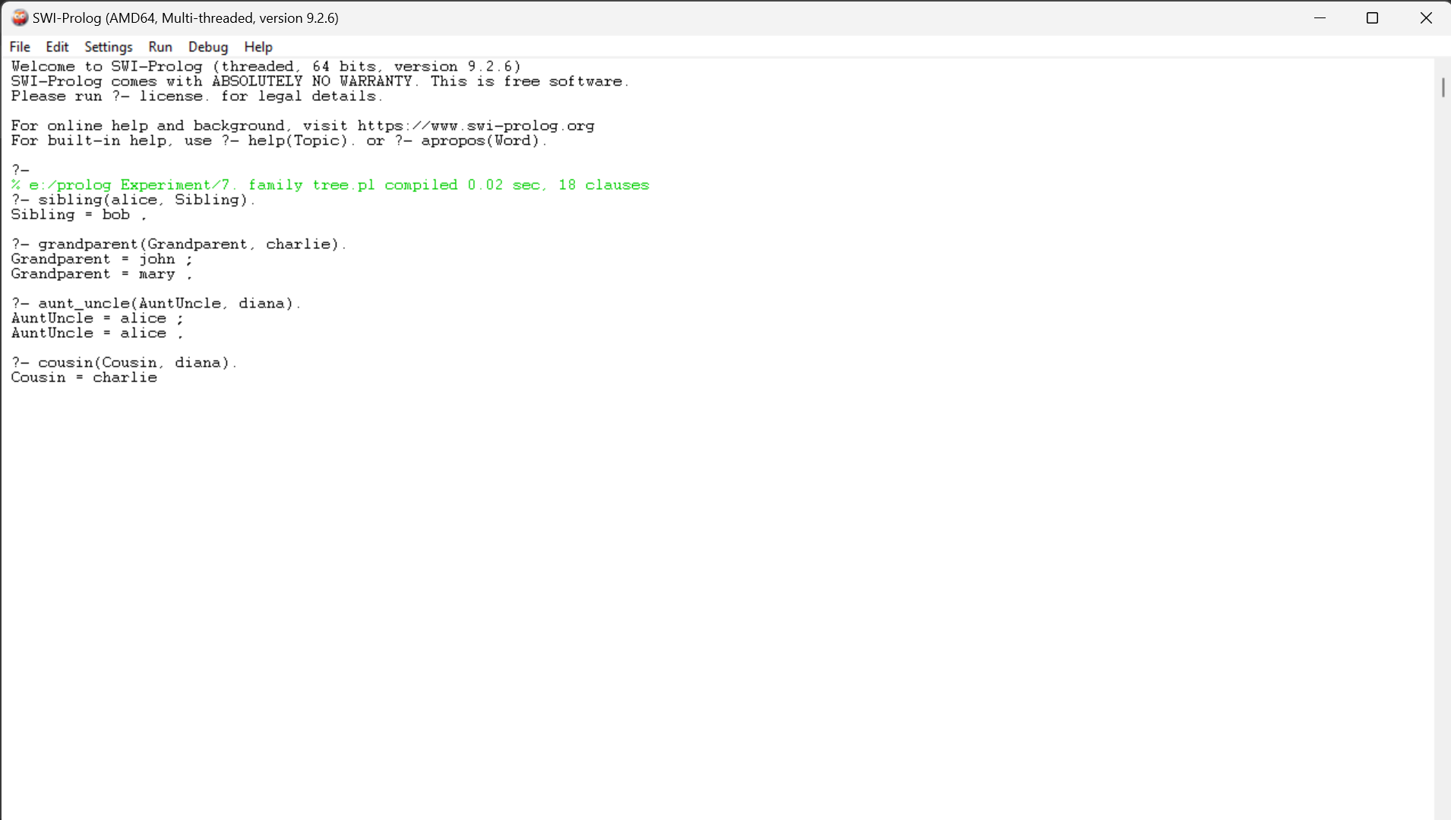

**24 Write a Prolog Program to suggest Dieting System based on Disease.**

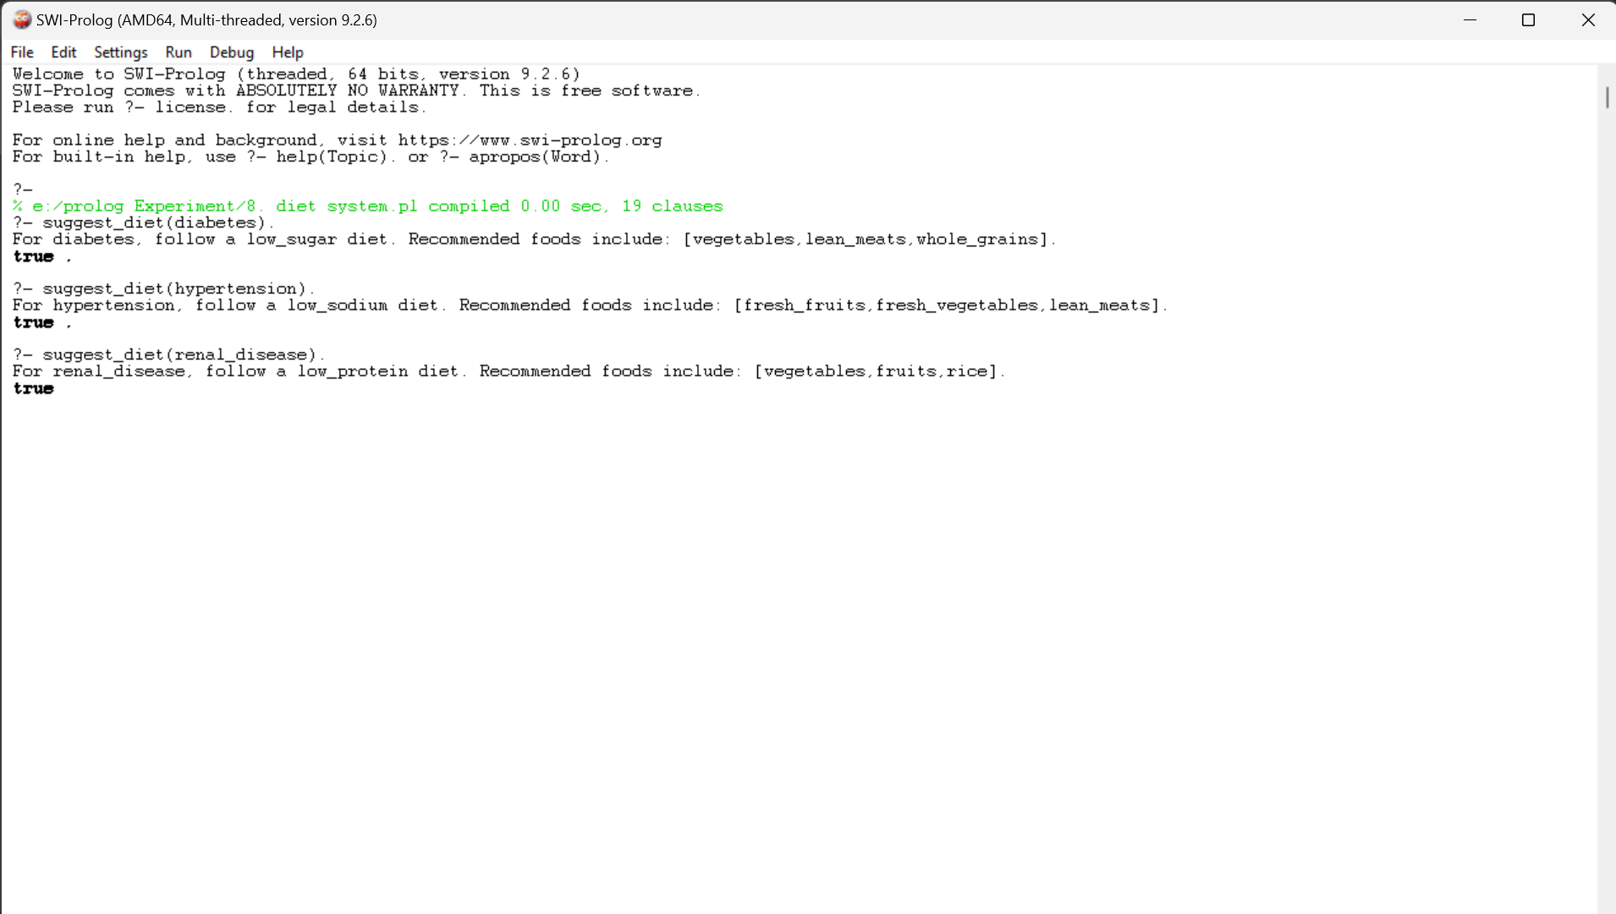

**25 Write a Prolog program to implement Monkey Banana Problem**

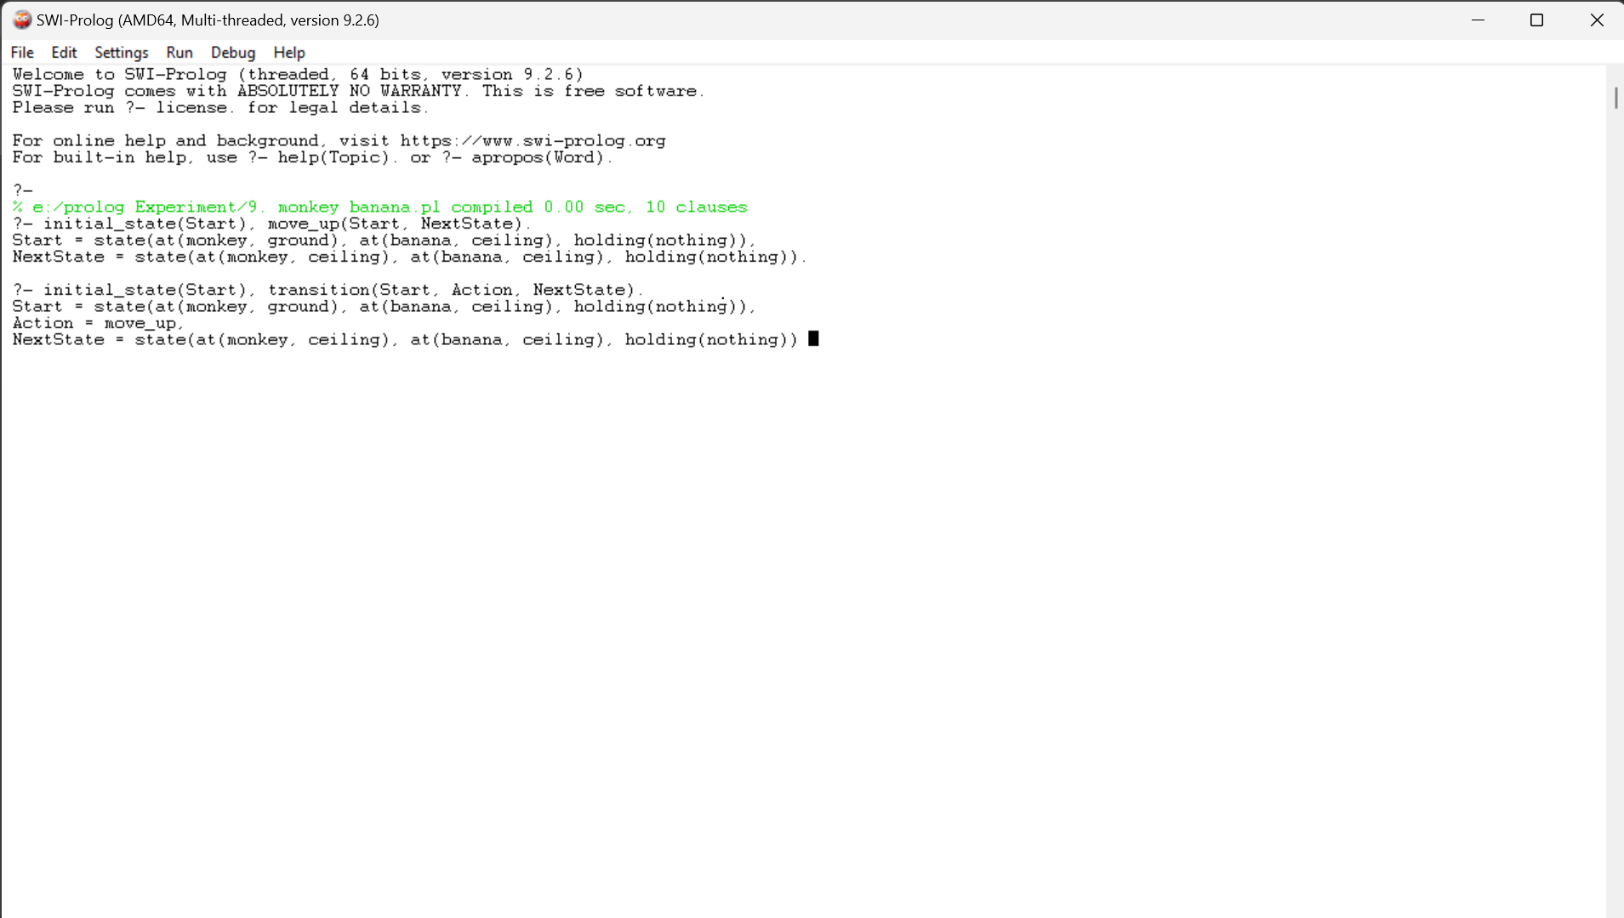

**26 Write a Prolog Program for fruit and its color using Back Tracking.**

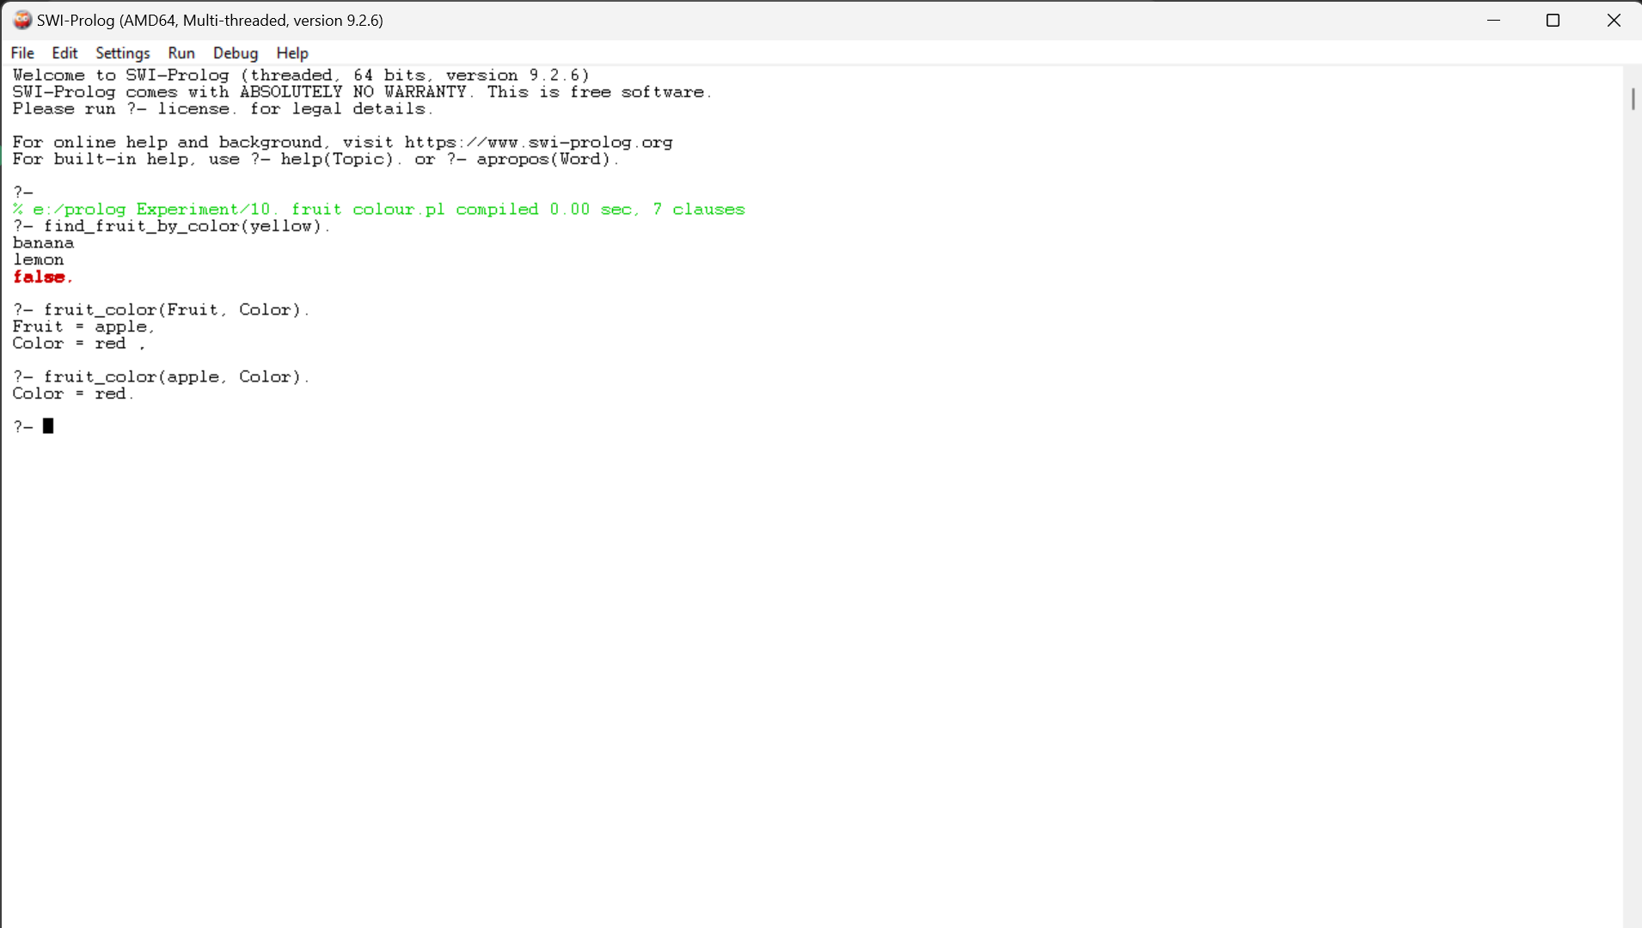

**28 Write the prolog program for Medical Diagnosis**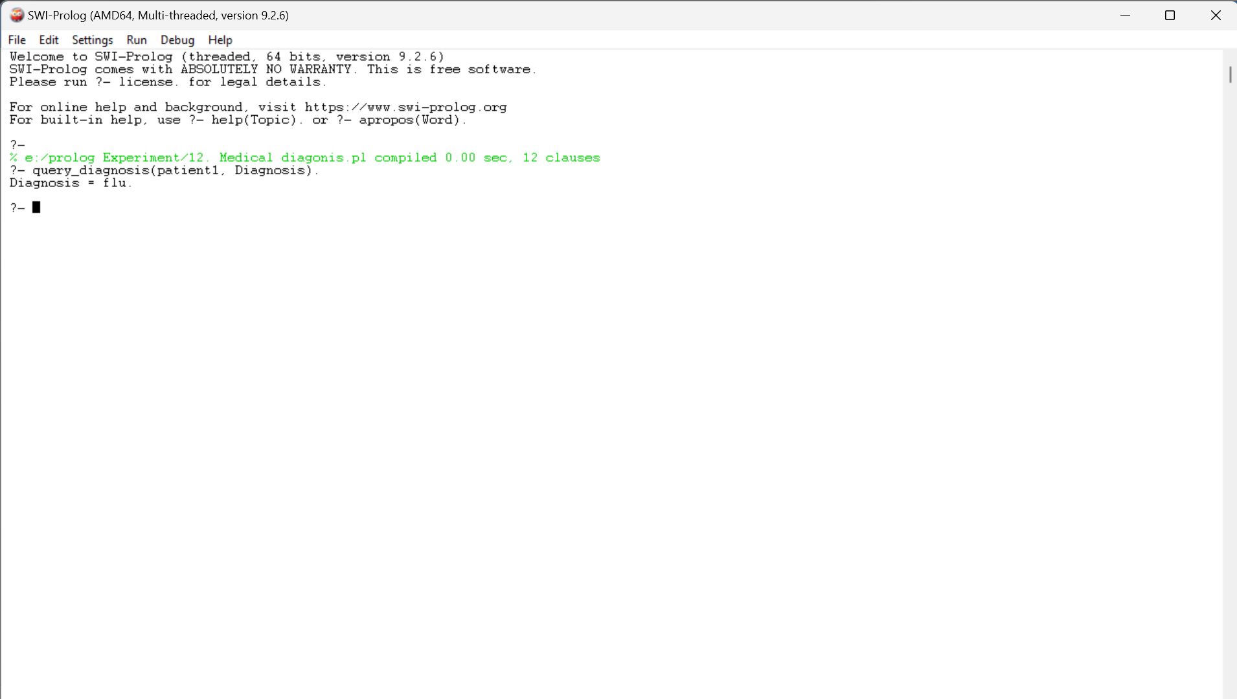

**29 Write a Prolog Program for forward Chaining. Incorporate required queries.**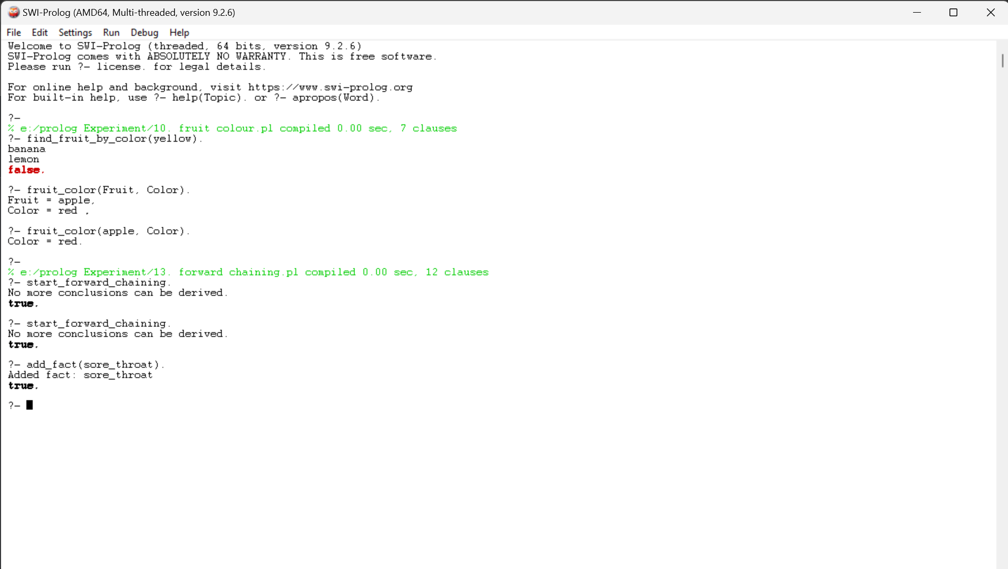

**30 Write a Prolog Program for Backward Chaining. Incorporate required queries.**

